**Steps to add Worker nodes to ECP Cluster**

1. Validate OS version and kernel version of worker node.

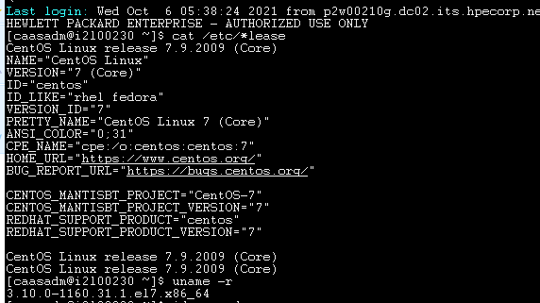

1. Run “id caasadm” command to check if caasasdm is added as group and “hostname” to validate hostname.



If not added run below commands:

usermod -a -G caasadm caasadm

groupadd caasadm

1. Run nslookup <hostname> to see if it is resolving

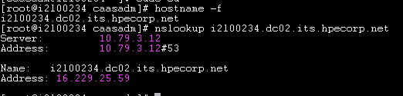

1. Run “ifconfig” and see if bond 0 is present with ip and other interfaces do not have any ip.

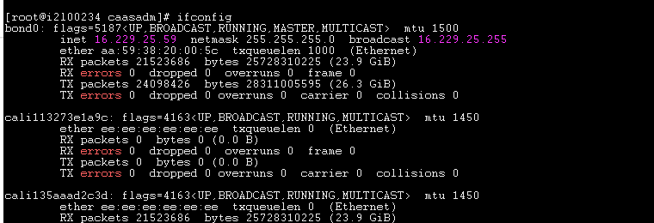

1. Do other necessary validations by running df-kh , lsblk and free -mh command as mentioned in Request number.
   1. Make sure we should not have noexec for /tmp (**not for BareMetals**)

*[root@i2lg551700 tmp]# mount | grep /tmp*

*/dev/mapper/systemlog-tmp on /tmp type xfs (rw,noexec,relatime,seclabel,attr2,inode64,noquota)/dev/mapper/systemlog-tmp on /var/tmp type xfs (rw,nosuid,nodev,noexec,relatime,seclabel,attr2,inode64,noquota)*

1. Edit below file



Add #Port22 (2nd line) after Protocol 2 line

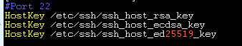

Add caasadm like below and save file



Make sure changes are added like above mentioned in file and there should not be any space otherwise you won’t be able to login to server.

1. Run systemctl restart sshd
2. Run yum install -y vim if vim is not installed :
3. Add caasadm as no password user both at group level and user level.

Run visudo edit it like below

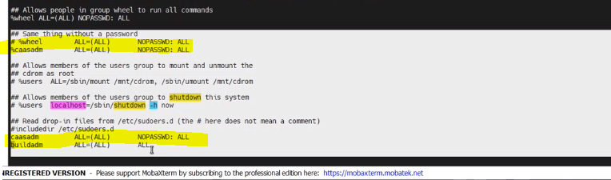

It should not ask for password prompt when entering as root user.

1. Remove python 3 related packages.

yum remove docker python3*

1. Downgrade openldap version if version is same as in screenshot below

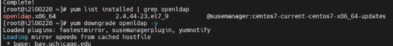

Verify openldap version



1. Goto Ansible toweràInventoriesàhpecp-itgàedit inventoryàhost

All nodes should be disabled. This should have ideally gateway and controller nodes.

In this example node 16.229.25.55 and .16.229.25,57 worker nodes were already present in enabled state. Click on edit and updated the ip to 16.229.25.59 and 16.229.25.53(baremetal node which we are going to add in ecp cluster). Node which is going to be added should be in enabled state.

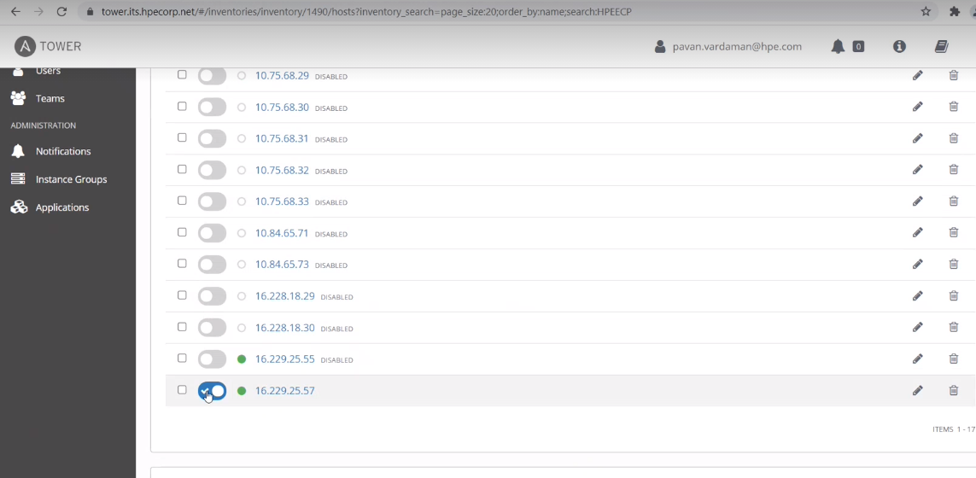

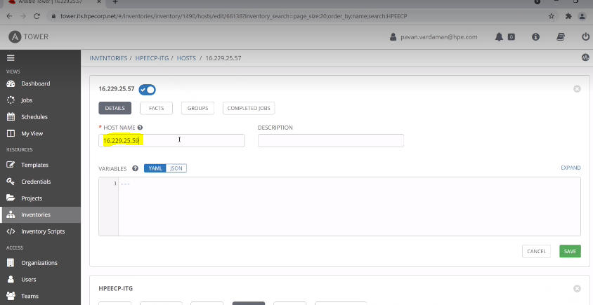

Goto template and run below highlighted playbook

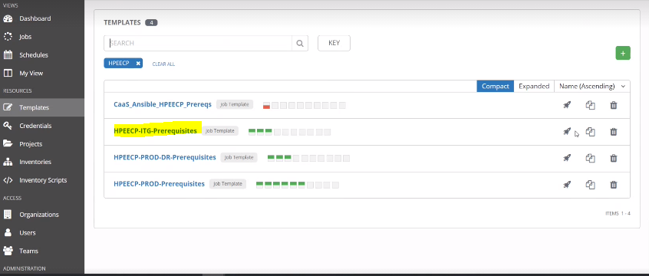

1. Goto primary controller node and ssh to worker node and see if you are able to ssh without providing password.
2. Login to worker node and edit below file

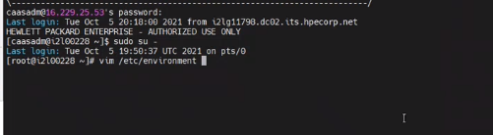

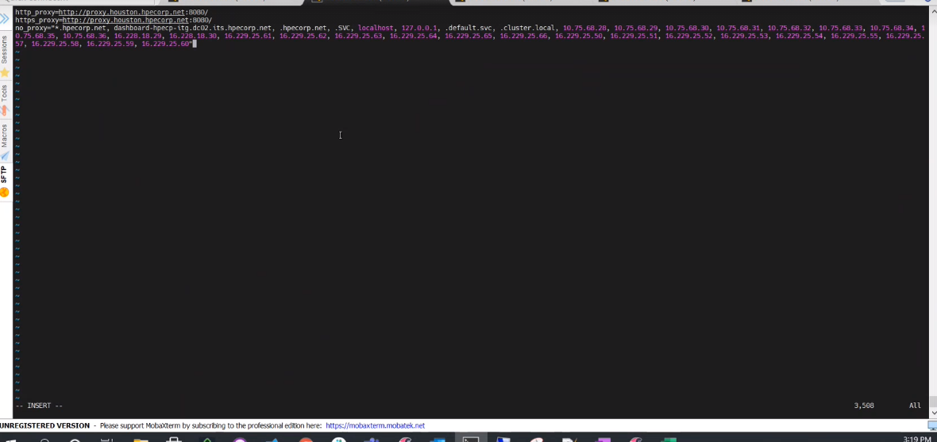

It should have all cluster ips with http_proxy, https_proxy,no_proxy.

Below is Example of ECP ITG :

http_proxy=http://proxy.houston.hpecorp.net:8080/

https_proxy=http://proxy.houston.hpecorp.net:8080/

no_proxy="*.hpecorp.net, dashboard-hpecp-itg.dc02.its.hpecorp.net, .hpecorp.net, .SVC, localhost, 127.0.0.1, .default.svc, .cluster.local, 10.75.68.28, 10.75.68.29, 10.75.68.30, 10.75.68.31, 10.75.68.32, 10.75.68.33, 10.75.68.34, 10.75.68.35, 10.75.68.36, 16.228.18.29, 16.228.18.30, 16.229.25.61, 16.229.25.62, 16.229.25.63, 16.229.25.64, 16.229.25.65, 16.229.25.66, 16.229.25.50, 16.229.25.51, 16.229.25.52, 16.229.25.53, 16.229.25.54, 16.229.25.55, 16.229.25.57, 16.229.25.58, 16.229.25.59, 16.229.25.60"

1. Next edit below file



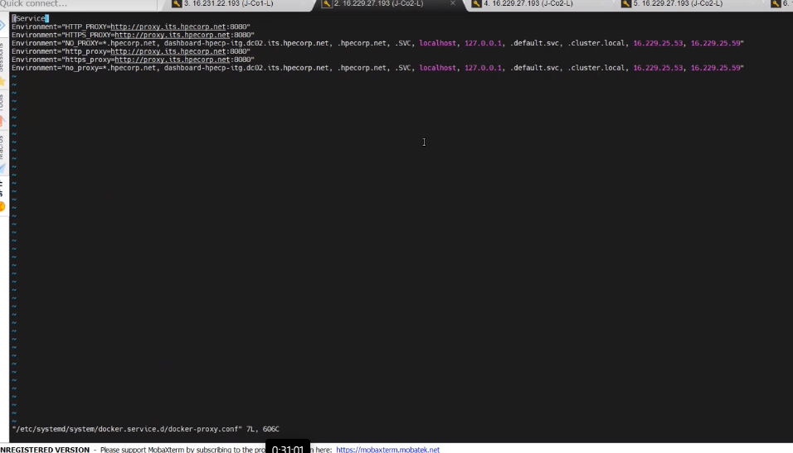

Replace content with below values(Below is Example of ECP ITG ):

[Service]

Environment="HTTP_PROXY=http://proxy.its.hpecorp.net:8080"

Environment="HTTPS_PROXY=http://proxy.its.hpecorp.net:8080"

Environment="NO_PROXY=*.hpecorp.net, dashboard-hpecp-itg.dc02.its.hpecorp.net, .hpecorp.net, .SVC, localhost, 127.0.0.1, .default.svc, .cluster.local, 10.75.68.28, 10.75.68.29, 10.75.68.30, 10.75.68.31, 10.75.68.32, 10.75.68.33, 10.75.68.34, 10.75.68.35, 10.75.68.36, 16.228.18.29, 16.228.18.30, 16.229.25.61, 16.229.25.62, 16.229.25.63, 16.229.25.64, 16.229.25.65, 16.229.25.66, 16.229.25.50, 16.229.25.51, 16.229.25.52, 16.229.25.53, 16.229.25.54, 16.229.25.55, 16.229.25.57, 16.229.25.58, 16.229.25.59, 16.229.25.60"

Environment="http_proxy=http://proxy.its.hpecorp.net:8080"

Environment="https_proxy=http://proxy.its.hpecorp.net:8080"

Environment="no_proxy=*.hpecorp.net, dashboard-hpecp-itg.dc02.its.hpecorp.net, .hpecorp.net, .SVC, localhost, 127.0.0.1, .default.svc, .cluster.local, 10.75.68.28, 10.75.68.29, 10.75.68.30, 10.75.68.31, 10.75.68.32, 10.75.68.33, 10.75.68.34, 10.75.68.35, 10.75.68.36, 16.228.18.29, 16.228.18.30, 16.229.25.61, 16.229.25.62, 16.229.25.63, 16.229.25.64, 16.229.25.65, 16.229.25.66, 16.229.25.50, 16.229.25.51, 16.229.25.52, 16.229.25.53, 16.229.25.54, 16.229.25.55, 16.229.25.57, 16.229.25.58, 16.229.25.59, 16.229.25.60"

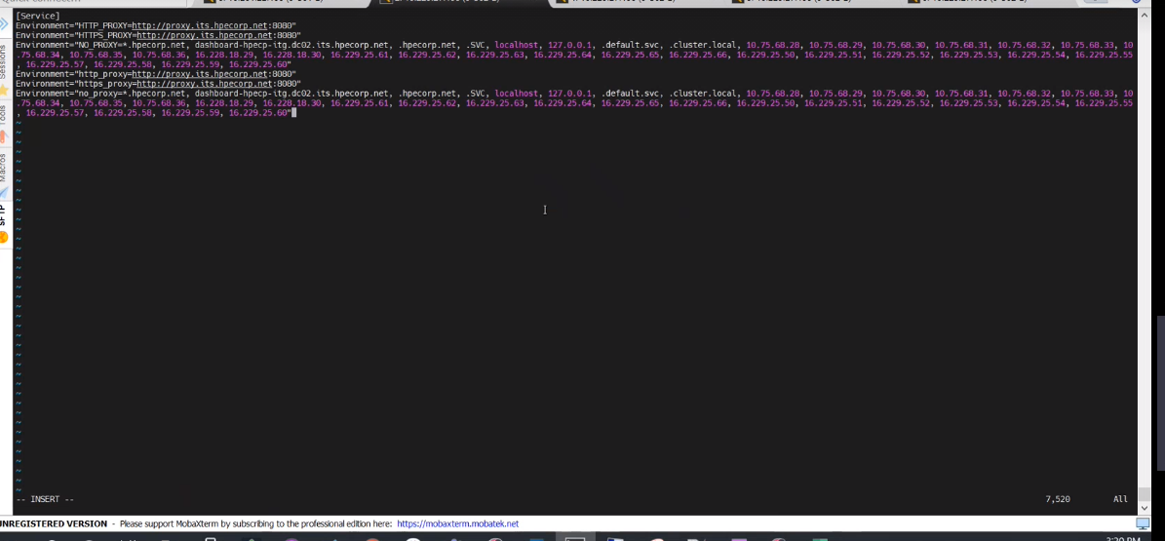

1. Edit below file



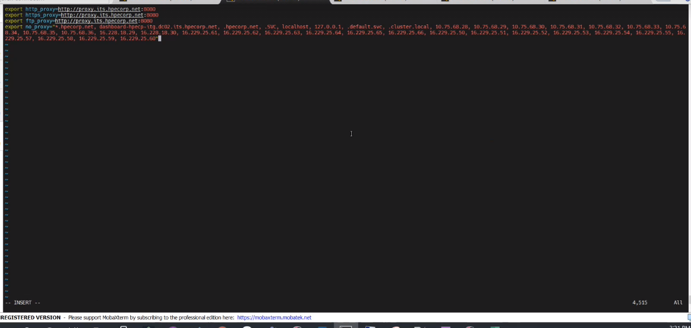

Replace with below values(Below is Example of ECP ITG )

export http_proxy=http://proxy.its.hpecorp.net:8080

export https_proxy=http://proxy.its.hpecorp.net:8080

export ftp_proxy=http://proxy.its.hpecorp.net:8080

export no_proxy="*.hpecorp.net, dashboard-hpecp-itg.dc02.its.hpecorp.net, .hpecorp.net, .SVC, localhost, 127.0.0.1, .default.svc, .cluster.local, 10.75.68.28, 10.75.68.29, 10.75.68.30, 10.75.68.31, 10.75.68.32, 10.75.68.33, 10.75.68.34, 10.75.68.35, 10.75.68.36, 16.228.18.29, 16.228.18.30, 16.229.25.61, 16.229.25.62, 16.229.25.63, 16.229.25.64, 16.229.25.65, 16.229.25.66, 16.229.25.50, 16.229.25.51, 16.229.25.52, 16.229.25.53, 16.229.25.54, 16.229.25.55, 16.229.25.57, 16.229.25.58, 16.229.25.59, 16.229.25.60"

1. Goto primary controller and get the private key:

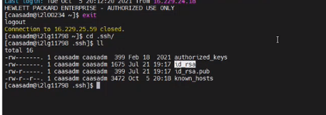

1. Login to worker node and goto /tmp and ls -lrt. Log File will be present here.



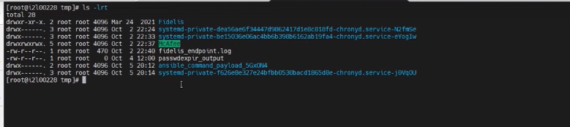

1. Run below command and validate nokemem:

cat /proc/cmdline



1. Goto Dashboardàhosts and enter details like below:

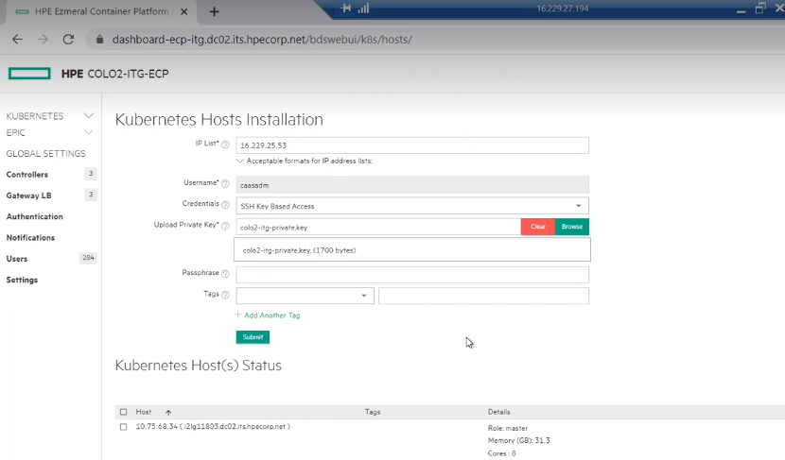

Click on submit and goto /tmp and do ls -lrt and see if executable is there

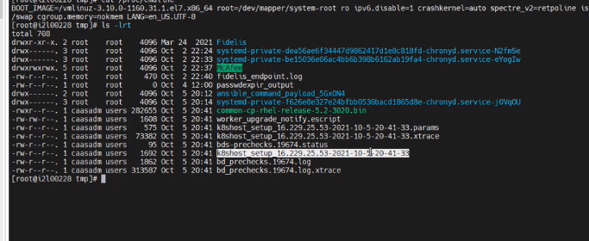

Run below command

tail -f k8shost_setup_16.229.25.59-2021-10-5-20-44-09

Make sure that Failed should be 0 and look for below message in logs which means phase 1 is completed.

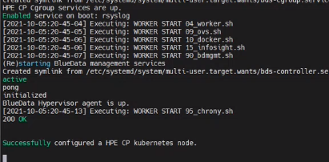

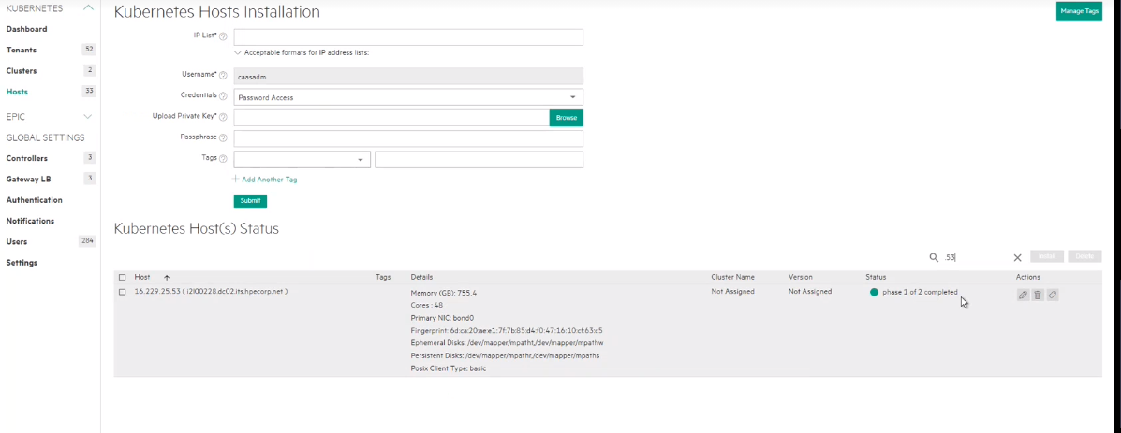

Click on edit and set disk space as mentioned in screenshot below:

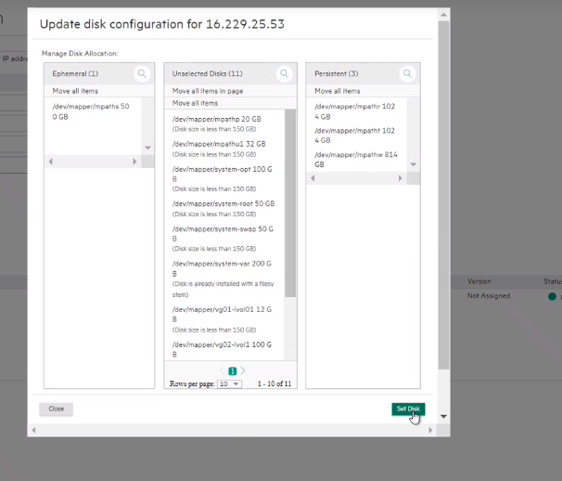

Click on checkbox and install. If more than one nodes need to be installed then take a break of 2 mins then click on install for other node

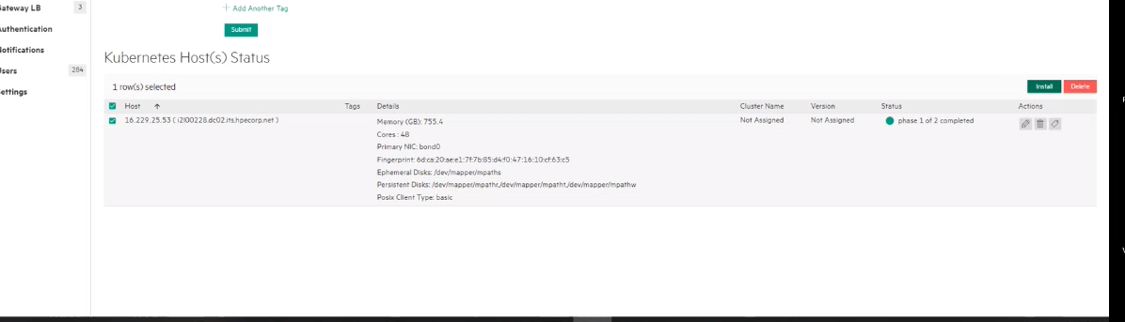

1. Run below command

cd /var/log/bluedata/install/

Run below command to see the logs while installation is happening.

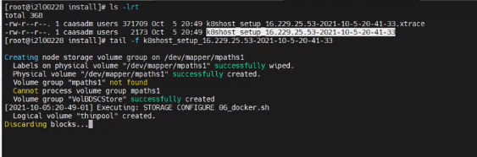

Once you see below message related to zookeeper that means phase 2 is completed.

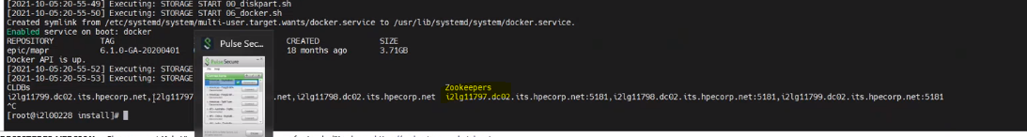

Nagios monitoring will be installed after this stage once installed then node will be in ready state.

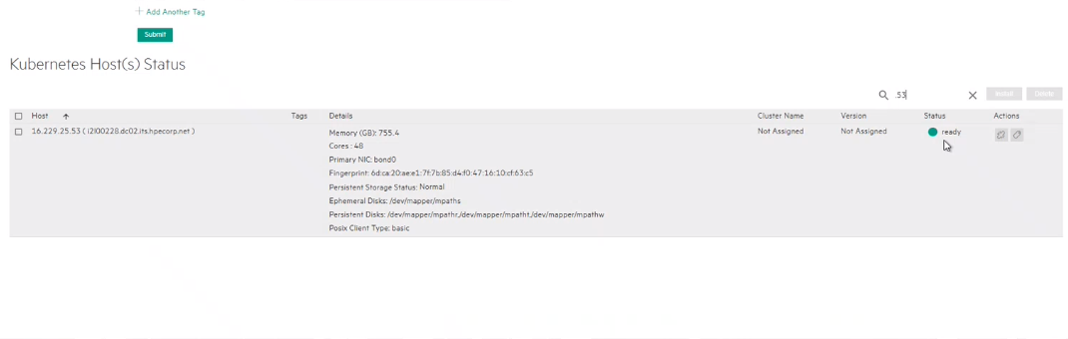

1. Run bellow command and perform docker login

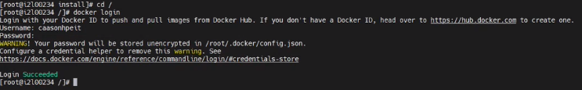

1. Open master agents in two terminals and run below command

Terminal1:

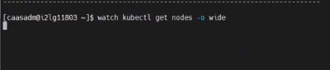

Terminal2:

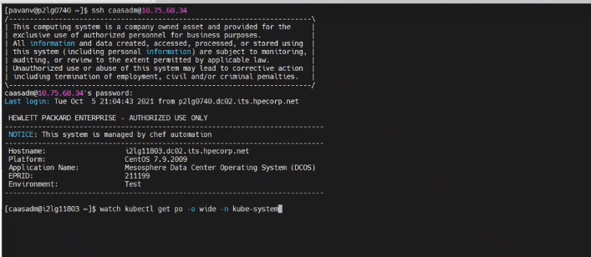

We will update the cluster, click on edit

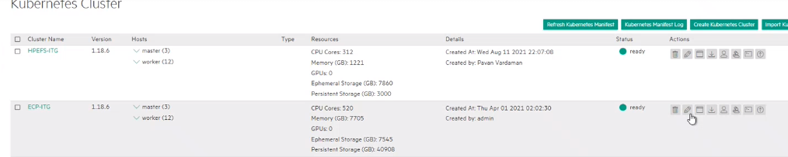

Set the configuration like below:

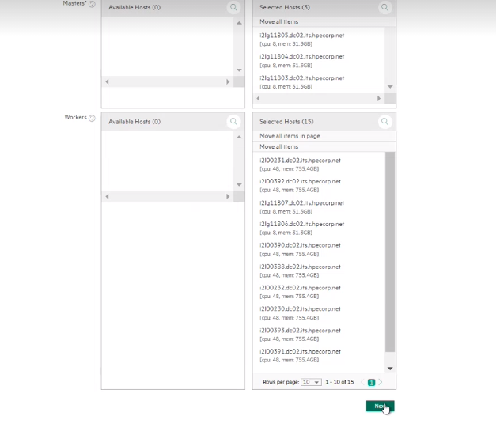

Keep Clicking on next and then submit

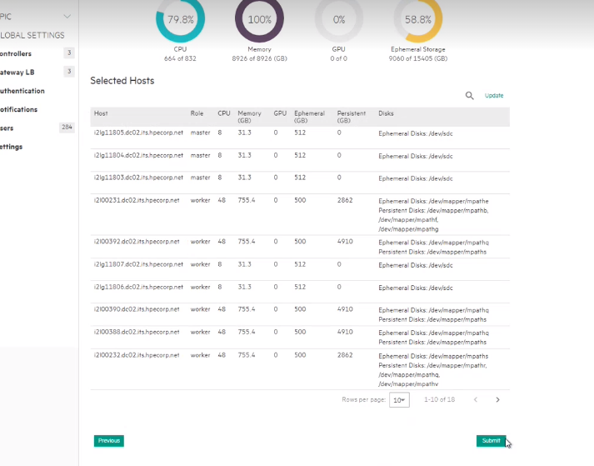

Keep monitoring the nodes and pods from both terminals.

Once nodes are added , check if pods are not in pullback state. If yes then need to update configuration

Run below commands:



1. Monitor nodes and pods until all nodes are in ready state. Check service status once nodes are added in cluster.

